Sharon Mor | Yuval Badihi

Advisor – Dr. Naomi Unkelos Spiegel

First Response Team Application

Table of Contents

ABSTRACT

This book addresses the critical need to enhance first response operations in increasingly diverse and unpredictable emergency environments. It highlights a significant challenge: the absence of an integrated system that effectively coordinates and bolsters the capabilities of first response teams, particularly in high-risk areas and places recently impacted by emergencies. In response, this book advocates for the creation of a sophisticated web and mobile application tailored to optimize communication and operational efficiency among first response units. This proposed tool is designed to support real-time strategic decision-making and serve as a robust platform for comprehensive emergency management, incorporating advanced features that simplify complex tasks and promote collaborative efforts during critical incidents.

To develop this foundation, the book will delve into the technical design, diagrams, and research that underpin the proposed tool. It will present detailed diagrams and discuss the theoretical frameworks that inform the system's architecture, aiming to provide a thorough understanding of the technological base. Additionally, the development process will include interviews with first responders and other stakeholders to gather direct insights that will influence the application’s features and functionality.

Furthermore, the book examines the application's potential to serve as a model for leveraging technology to elevate emergency management practices. It offers insights into its applicability and the broader implications for technological advancements in the field, aiming to significantly enhance the responsiveness and effectiveness of emergency response teams.

INTRODUCTION

In today’s rapidly evolving world, first response and resilience teams are more crucial than ever, especially in areas susceptible to crises or conflict. These teams, which span diverse sectors including health, education, and logistics, are often the first line of defense in emergencies, providing vital support until additional resources can be mobilized. The necessity for effective management systems became particularly evident following the significant events of 7.10, which underscored the urgent need for comprehensive and robust emergency management systems capable of handling both routine operations and crisis situations.

Our project aims to develop an innovative application designed to significantly enhance communication and decision-making among first response and resilience teams. The planned application will integrate a centralized platform for coordination, bringing structure and efficiency to the often chaotic environment of emergency management. This will allow users to tailor their responses dynamically through features like alarm creation and task assignment[3].

The application will be developed using advanced web technologies such as React and for mobile platforms through React Native, ensuring seamless functionality and accessibility across different devices. It is intended to integrate critical features like real-time location tracking and hazard marking systems, coupled with comprehensive tools for task management and alert administration.

Moreover, the application will emphasize the crucial differentiation between the 'response' and 'recovery' phases of emergency management. This distinction is expected to help teams manage incidents more effectively from their onset through to their conclusion. Additionally, the application will support archiving and retrieving past incident data, enabling teams to continuously learn from previous experiences and improve their preparedness for future emergencies[3].

The success of this application will be built on its foundation in well-established emergency response principles. Drawing insights from leading practices on organizing effective emergency teams[1] and enhancing the capabilities of disaster responders[2], the application is being designed to improve the operational effectiveness of emergency teams. These principles guide our approach to ensure teams are well-prepared and equipped to manage crises effectively.

This introduction outlines the development goals, intended functionality, and potential impact of this innovative tool. It sets the stage for a comprehensive exploration of how this technology promises to revolutionize operations and significantly boost crisis management effectiveness across various communities.

BACKGROUND AND RELATED WORK

**Background**

The creation of the First Response Team application was driven by a series of critical incidents that clearly showed the shortcomings in emergency response coordination. Among these, the events of October 7th were particularly notable, revealing a system with poor communication and lacking a unified management platform, which greatly reduced the efficiency of rescue operations. To deeply understand these challenges, we began an extensive dialogue with emergency responders working in high-risk areas, such as the Golan settlements. These discussions made it clear: the tools available to first responders—sufficient for everyday use—were not up to the demands of emergency situations that require speed, precision, and reliability.

This lack of effective communication tools highlighted a pressing need for a custom solution designed specifically for the unique challenges of emergency response work. The general-purpose communication apps lacked key features such as real-time location tracking, secure data transmission, and simple interfaces necessary in stressful conditions. This insight was the foundation for developing an application that could overcome traditional communication barriers and serve as a crucial support in crisis situations.

**Motivation**

Driven by the urgent need to improve the operational capabilities of first responders, we embarked on creating the First Response Team application—a tool built from scratch to meet the specific needs of emergency response teams. Our motivation is dual: to make the communication process more efficient and to provide responders with a tool that bolsters their ability to act quickly and decisively.

The main aim is to develop a unified platform that not only simplifies the complexities of emergency management but also boosts the confidence of teams on the ground. By incorporating advanced features like encrypted real-time communication, intuitive user interfaces, and automated logistical support into a single application, we aim to transform how first response teams work during emergencies.

Moreover, we are dedicated to making sure that the application is accessible and easy to use, even in the most stressful conditions. This commitment comes from a thorough understanding of the chaotic environments in which first responders operate—a setting where cumbersome technology can be more of a barrier than an aid.

In summary, our goal is to do more than just provide a tool; we aim to create an essential partner in the field of emergency response. We strive to have a substantial impact on the efficiency of first response teams, ultimately enhancing outcomes in crisis situations and saving lives.

**RELATED WORK**

| **AVUKA SQUAD** | **Zello** | **AVIA** | **Feature** |
| --- | --- | --- | --- |
| X | V | V | IOS Support |
| V | V | V | Android Support |
| X | V | V | Web/PC Support |
| V | X | V | Management App |
| X | V | V | Resident's App |
| X | X | V | Wellness Check |
| X | X | X | Automatic Dialling Emergency Services |
| V | X | V | Google Maps |
| V | X | V | Dynamic Map |
| V | X | V | GPS Tracking |
| V | X | X | Sectors In Map |
| V | X | X | Freehand Marking |
| V | X | X | Navigation Option |
| X | X | X | 3D Map |
| V | V | X | Push-To-Talk |
| V | V | V | Chat |
| V | V | V | SOS Alarm |
| V | V | V | Alert For FRT Activation |
| V | X | V | Predefining Possible Emergency Events |
| V | X | X | Execute Exercise |
| V | V | V | Defining Groups |
| V | V | V | Operation Logs |
| V | X | V | Message Board |
| X | X | V | Forces Count |
| X | X | X | Performance Monitoring |
| X | X | X | Integration With Cameras |
| X | X | X | Smooth Registration |

סקירת ספרות - להוסיף רפרנסים ולהסביר על מושגים כמו מה זה כיתת כוננות  
Existing First Response Team Tools



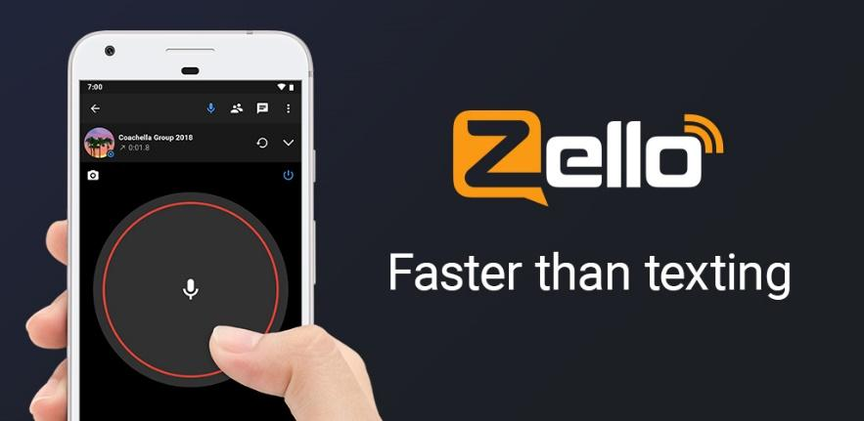



As we examine the landscape of applications designed for First Response Teams, we observe a suite of tools with the potential to transform the efficacy of emergency management. From the direct communication capabilities of Zello to the comprehensive control offered by Avuka Squad and AVIA, each application contributes uniquely to the toolkit of first responders. However, as our comparison table illustrates, while these applications address certain facets of first response needs, they each lack some critical features that are necessary for a fully integrated response solution.

Zello, known for its push-to-talk functionality, simplifies real-time voice communication, a crucial element during emergencies. Avuka Squad and AVIA, on the other hand, extends its utility to a broader range of emergency management tasks. Yet, neither of these solutions fully encapsulates the breadth of tools required to manage complex situations that first responders frequently encounter.

The cornerstone of our goal is to bridge these gaps, creating a solution that not only encompasses the most vital features needed for effective first response but also maintains simplicity at its core. We understand that in the throes of an emergency, first responders cannot afford to grapple with a complex application interface. Time is of the essence, and cognitive loads must be minimized to focus on the task at hand.

לכתוב כמה משפטים / סיכום קצר על מה חסר באפליקציות

**Application - גם חלק מהסקירה  
לשלב רפרנסים**

**Web Application and Mobile Application Development**

In today’s technological landscape, effective and intuitive applications are crucial for the efficient management of first response teams. Our system includes both web and mobile applications, tailored to meet the diverse needs of the team. By integrating these platforms, we leverage the unique advantages of each to enhance overall system functionality.

The web application provides a stable and scalable platform suitable for complex data management and operational oversight. Conversely, the mobile application offers unparalleled convenience, ensuring that first responders stay connected and well-informed even during active operations.

Together, these applications support enhanced communication, seamless data sharing, and more effective emergency management, boosting the effectiveness of the response team.  
  
**Web Application Development**

Web applications are becoming more popular due to their ease of use and maintenance. These applications are stored on cloud or dedicated servers, ensuring they are always available with a very low risk of data loss. Anyone with a device that has a web browser can access these applications, which is especially useful for systems that need quick updates or immediate access to data, like first response team control systems.

Developing a web application is generally quick, allowing teams to have a working product ready in a short amount of time. The availability of numerous libraries and third-party tools today eases the development process, enhancing both productivity and efficiency. Moreover, web applications facilitate effective teamwork by enabling easy collaboration and swift updates, which are essential in emergency response scenarios where coordination and timely action are crucial.

However, there are challenges:

Performance: Web applications depend on the browser's performance. Large-scale applications can be slow and may experience downtime or crashes.

Security: The reliance on Internet connectivity increases vulnerability to security breaches. Leveraging established technologies with proven security protocols helps mitigate these risks significantly. Despite these precautions, the threat of hacking and data theft remains a concern, underscoring the need for continuous security enhancements and monitoring.

**Mobile Application Development**

Mobile applications offer distinct advantages for a first response team application, primarily through enhanced accessibility and user engagement. Mobile apps can provide tailored experiences optimized for handheld devices, crucial for first responders who rely on quick, easy-to-navigate interfaces in emergency situations.

The development of mobile applications allows for:

Offline Access: Unlike web applications, mobile apps can offer limited functionality even without an Internet connection, crucial during emergencies in remote or network-compromised areas.

Notifications: Mobile apps can send instant notifications to users, which is vital for updating first responders about urgent situations or new information.

Enhanced Security: Mobile platforms often incorporate robust security measures that protect sensitive data, crucial for an application handling critical first response information.

Like their web counterparts, mobile applications face certain drawbacks:

Compatibility: Developers must ensure the application runs smoothly across various devices and operating systems, which can complicate development.

Maintenance: Mobile applications require regular updates to address system vulnerabilities and compatibility issues, which can increase operational burdens.

In conclusion, integrating both web and mobile applications for controlling first response teams ensures maximum coverage and functionality. Each platform complements the other by addressing specific needs and operational scenarios, thereby providing a comprehensive toolset for effective emergency management.

**Engineering Process  
  
לכתוב מילים על התהליך שעשינו המוביל אותנו להחליט על הארכיטקטורה הזאת**

**הוספת תרשים  
  
System Architecture**

Our system architecture is designed to ensure seamless interaction between web and mobile platforms, utilizing a robust suite of technologies to deliver secure, efficient, and responsive applications. Central to our approach is the use of modern frameworks and tools across both front and backend implementations, supported by advanced data handling and authentication systems. This architecture not only enhances user experience but also maintains system integrity and scalability as demands grow. Below, we outline the specific technologies and configurations employed in each segment of our system:

**Web Application Architecture**

The web application architecture is built using React and Node.js, leveraging Firebase Auth for authentication and MongoDB for data storage. Here's how each component functions within the system:

* **React:** Handle the user interface (UI) and user interactions. React's efficient update and rendering system make it ideal for responsive web applications.
* **Node.js:** Manages server-side logic and handles API requests and responses. It serves as the central communication point with various databases, ensuring efficient data management and scalability.
* **Express.js:** Utilized as the web application framework running on the Node.js server, Express.js simplifies the routing and middleware architecture, enhancing API development and server management for mobile applications.
* **Firebase Auth:** Manages user authentication and session management, ensuring secure access to the web application.

**Mobile Application Architecture**

The mobile application leverages the synergy of React Native and a dedicated Node.js backend, incorporating Firebase Auth for secure authentication and MongoDB for robust data storage. Here is an overview of each component's role within the mobile ecosystem:

* **React Native:** Takes charge of the mobile user interface (UI) and user interactions. Its use of native components ensures that the mobile application delivers a responsive and fluid experience akin to native applications.
* **Node.js:** Manages server-side logic distinctively for the mobile context. It processes API requests and responses specific to the mobile application, acting as a liaison for mobile-specific data flows and services.
* **Express.js:** As the web application framework running on the Node.js server, Express.js is crucial for handling the RESTful API endpoints that the mobile app utilizes to communicate. It is tailored to manage mobile session states and optimize API responses for low-latency communication essential in mobile environments.
* Firebase Auth: Handles secure user authentication for the mobile application. It ensures that user sessions are managed securely, facilitating reliable access to mobile-specific features and services.

**Data Storage and Search Technologies**

Before detailing the middleware server, it is important to outline the key data storage and search technologies employed:

* **MongoDB:** Serves as the primary database, storing application data in a NoSQL format which allows for flexible, schema-less data structures, making it ideal for applications that require quick iterations and adaptations.
* **Elasticsearch:** Provides powerful search and analytics capabilities with near real-time indexing, greatly enhancing the application’s ability to perform complex searches, data visualization, and real-time analytics.

**Middleware Server Architecture**

To enhance performance and scalability, a middleware server written in Java or a similar robust language is incorporated, serving as an advanced processing layer that interacts with various databases and services:

* **Middleware Server:** Acts as a robust conduit between the web and mobile backends and the databases. It manages more complex queries and operations that are beyond the scope of regular backend functions.
* **Database Communication:** The middleware server uses MongoDB for sophisticated data manipulations and retrievals, efficiently managing large-scale data operations.

Elasticsearch Integration: The middleware server also integrates with Elasticsearch to harness its advanced search capabilities, providing quick data retrieval and real-time analytics.

Additional Functionalities: Can also integrate other third-party services and APIs, providing a flexible and scalable environment to meet growing application demands.

**Conclusion**

This comprehensive system architecture supports robust scalability, advanced security, and high efficiency, making it well-suited for demanding environments. By utilizing React and React Native for frontend development and Node.js for backend operations, the architecture ensures a unified development approach and optimal resource utilization across both web and mobile platforms. The addition of MongoDB and Elasticsearch enhances the system's data handling and search capabilities, while the middleware server ensures complex operations are managed effectively, keeping the application scalable and responsive as user demands increase.

**System Architecture:**

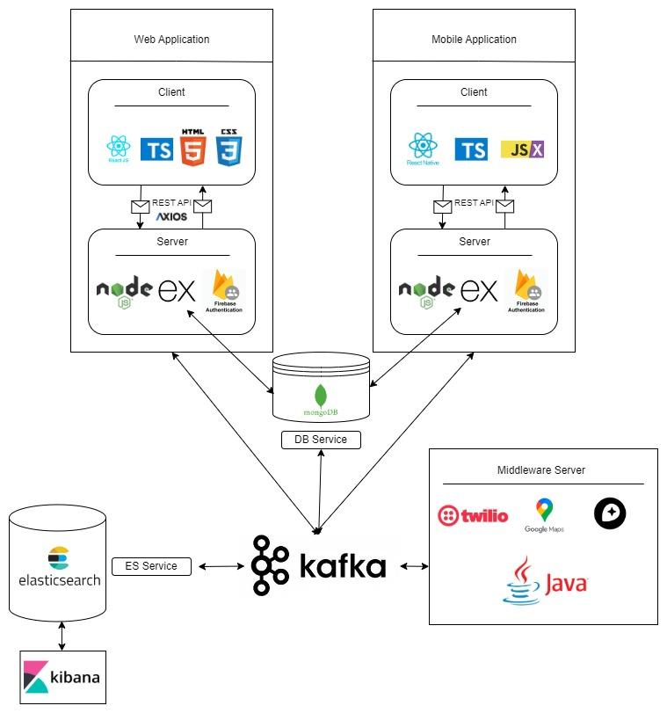

**Client-side technologies:**

React and React Native are two powerful frameworks developed by Facebook for building user interfaces. While React is primarily used for web development, React Native extends its capabilities to mobile app development. Both frameworks share many similarities, such as their language and syntax, but they also have distinct features tailored to their respective platforms. In this comparison, we'll explore the key differences between React for web and React Native for mobile, focusing on various aspects such as performance, testing, user interface, scalability, and community support.

| **Feature** | **React (Web)** | **React Native (Mobile)** |
| --- | --- | --- |
| **Language and Syntax** | JavaScript and JSX for creating UI components with the ease of HTML-like syntax embedded in JavaScript. | JavaScript and JSX, translating to native platform components for a seamless mobile experience. |
| **Performance** | Uses Virtual DOM for efficient updates. Calculates differences and re-renders only the changed parts on the real DOM. | Employs Virtual DOM and native views for a performance-optimized mobile experience. |
| **Testing** | Jest for testing framework. Enzyme and React Testing Library for testing components in isolation. | Jest for testing framework. React Native Testing Library for mobile-specific testing, including native behaviours. |
| **User Interface** | Component-based, declarative views making the code predictable and debuggable. | Component-based, declarative views with native platform UI elements integration. |
| **Web Support** | Cross-browser compatibility and SEO-friendly features. | Cross-platform compatibility with access to native device features like camera and storage. |
| **Scalability** | Designed for large-scale web applications, it can handle complex architectures and traffic volumes. | Suitable for large-scale mobile applications with the ability to integrate with native modules for enhanced performance. |
| **Community** | Large, active developer community with a rich ecosystem of libraries and tools. | Rapidly growing community with increasing contributions and an evolving ecosystem. |
| **Accessibility** | ARIA (Accessible Rich Internet Applications) standards support for web accessibility. | ARIA support plus native mobile accessibility features like VoiceOver and Talkback for an inclusive user experience. |

During our research about the client-side possible tools we found out that for our use case of building an application both for web and mobile, react and react native a good solution [4].

**Server-side technologies:**

Our application architecture is designed to effectively serve both web and mobile clients through a robust backend that scales and adapts to the needs of both platforms.

**Node.js:**Node.js is a versatile platform for building a variety of server-side and networking applications. Renowned for its non-blocking, event-driven architecture, it’s particularly adept at managing multiple simultaneous connections with high throughput, which makes it a suitable choice for high-load applications. Node.js brings the familiarity of JavaScript to the server-side, allowing developers to use a single programming language across both front-end and back-end.

**Express.js:**Built on top of Node.js, Express.js is a minimalist and flexible web application framework that provides a robust set of features to develop web and mobile applications efficiently. It simplifies the server creation process with its middleware framework, making it easy to perform tasks like parsing request bodies, managing cookies, and implementing sessions. Express.js is designed to be a lightweight framework that gives you the tools to create a server quickly while also being robust enough to manage web application routes, handle requests, and serve responses. Its ability to create a REST API makes it a powerful tool for backend development, facilitating seamless front-end to back-end integration.

**MongoDB:**MongoDB is an open-source NoSQL database that leverages a flexible document model for storing data. It’s well-suited for applications that need quick iterations and can manage diverse sets of data types. MongoDB’s schema-less nature allows it to handle large volumes of disparate data, which can be particularly useful for applications that require agility in data management and design.

**Elasticsearch:**  
Elasticsearch is a powerful open-source search and analytics engine that allows applications to perform complex searches, real-time data analysis, and visualizations. It enhances our application by enabling fast and scalable search capabilities, crucial for handling large datasets and providing real-time responses to user queries.

**Firebase Authentication:**Firebase Authentication provides a complete identity solution, supporting a variety of authentication methods, including social media accounts, phone numbers, and email/password. It integrates with Firebase's real-time database, which synchronizes data across all clients in real-time. This combination allows for the implementation of secure, authenticated user access to your application's data. Firebase's real-time database uses JSON documents and offers offline data synchronization and retrieval, enhancing the user experience even when connectivity is intermittent.

In summary, the combination of Node.js, Express.js, MongoDB, and Firebase Authentication forms a comprehensive server-side stack that facilitates the development of modern, scalable, and real-time web applications. Each component plays a crucial role in the system: Node.js serves as the runtime environment, Express.js adds structure and features for web application development, MongoDB provides a flexible data storage solution, and Firebase Authentication handles secure user management and real-time data synchronization.

**3) Workflow**

**3.1 Progress Mode Diagram:**

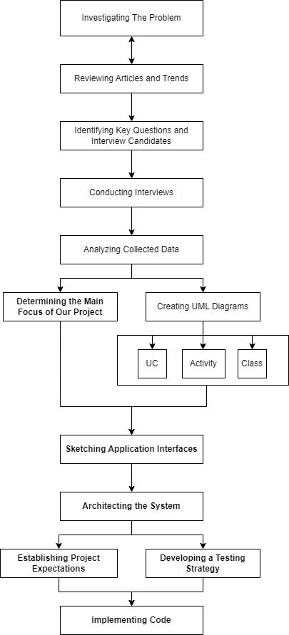

**3.2 Interviews**

**1) Muli Spiegel  
 Architect, Director of Engineering and Planning Department, The settlements in the Golan. Head of logistics infrastructures in emergency**

**Introduction:**

The interview was conducted with Muli Spiegel, Director of the Engineering Department, via phone call on April 26, 2024, at 11 AM Israel Time. The main goal was to understand the operations of the first response team in the Golan settlements.

**Background Information:**

Muli oversees logistics for his settlement's first response team, which is well-maintained and taken very seriously. The team is structured into specialized units responsible for Medical, Psychological, Logistics, Combat, Rescue, and other emergency responses. This division is a common organizational strategy across many towns in the Golan settlements.

**Key Insights: בולטים**

Our discussion with Muli highlighted the necessity of designing a system that effectively delineates and connects various operational 'circles' or teams. These could be geographical, as in towns within the same settlement, or functional, as in different emergency response units. It's essential to facilitate proper communication among these circles, recognizing that while each team has distinct requirements, they share core attributes that necessitate coordination.

**Challenges and Limitations:**

Muli shared insights from his research on the towns near Gaza, suggesting that improved inter-town communication could have mitigated civilian damages in past events. The absence of such communication underscores a significant challenge**.**

**Existing Solutions:**

According to Muli, many teams currently rely on WhatsApp for communication. He is aware that some settlements have adopted specialized applications to aid in coordination, yet there is no unified platform that meets the diverse needs of all teams across the settlements.

**Additional Notes:**

Muli recommended engaging with leaders of various emergency teams for more direct insights and has facilitated connections to them.

**Conclusion:**

A key takeaway is the need to develop a universal, yet adaptable, framework that meets the collective and individual needs of all emergency teams. Critical to this will be the strategic planning of the circles—both geographic and functional—that are essential for organized and efficient response coordination.

**2) Roee Tavor** Chairman of the Residential Resilience Team in Kanaf settlement (southern Golan Heights)

**Introduction:**

The interview was conducted in person with Roee Tavor, who leads the residential resilience team in Kanaf, on May 1st, 2024, at 12 PM Israel Time. The primary purpose was to learn how resilience and first response teams in a high-risk settlement function during normal conditions and emergencies.

**Background Information:**

Kanaf operates in a highly organized manner, with the resilience team collaborating closely with the first response team. The resilience team includes several groups: health, logistics, welfare, education, and spokesperson. Roee voluntarily leads the residential resilience team in Kanaf. The first response team consists of 30 members, while each resilience team has around 5 members.

**Key Insights:**

After our discussion with Roee, we realized that the management of emergency teams, both during routine and crisis situations, needs improvement. We learned that even high-risk settlements like Kanaf rely on WhatsApp and phone calls to manage operations, and that a user-friendly interface could enhance the effectiveness and usability of the different teams. Roee emphasized the need for an app that integrates all aspects of both routine and emergency operations and facilitates communication among the teams. For routine operations, he suggested incorporating as many useful features as possible to manage the teams. However, during emergencies, the focus should be on essential features to ensure the first response teams can operate effectively. Roee also mentioned the need for an interface that serves the entire Regional Council to provide a broader and cross-settlement perspective. Furthermore, he highlighted the importance of integrating the mobile app with a desktop version, envisioning a setup where a computer using the desktop version could mark important details on the application’s map, helping mobile users see updates and allowing the coordinator to maintain an overview of the situation.

**Challenges and Limitations:**

Roee pointed out several challenges and limitations that are likely to arise. For instance, he expects a lack of GPS availability, which is crucial during both routine and emergency situations. He also noted that internet connectivity might be lost during emergencies, further complicating communication and coordination. Additionally, Roee emphasized the importance of the application having all the features currently in use; he mentioned that they had previously tried an app that was missing some essential features, leading them to abandon it and revert to using WhatsApp groups. To ensure the new app is adopted and utilized, it must fully accommodate their operational needs.

**Existing Solutions:**

Currently, the coordination of patrols and shifts for the locals is managed using an Excel spreadsheet. Additionally, each residential resilience team and first response team communicates and organizes via separate WhatsApp groups.  
 Roee also mentioned that both the response team and the residential resilience team use a 'Motorola,' which is a walkie-talkie communication tool operating on different radio frequencies. Therefore, integrating a similar feature into our app would be unnecessary, as they would not use it at all if it were included.

**Additional Notes:**

Roee highlighted that they make an effort to document every significant event. For instance, after a real event, they try to create a comprehensive file that details everything that happened and what could be improved. However, he also noted that such files are typically shared via WhatsApp and tend to get lost in the chat history, making them difficult to track and reference later.

**Conclusion:**

The interview with Roee Tavor provided valuable insights into the operational challenges and needs of the residential resilience and first response teams in Kanaf. The reliance on basic tools like WhatsApp and Excel sheets for critical communication and coordination highlights the necessity for a more robust, integrated application tailored to both routine and emergency scenarios. The new app must encompass all existing functionalities to ensure adoption and must be reliable even in conditions where GPS and internet connectivity are compromised. Additionally, improving the documentation and accessibility of important post-event reports is essential for ongoing improvement and accountability. This conversation underscores the importance of developing a user-friendly, comprehensive tool that supports the unique demands of high-risk settlement operations.

**3) Hagit Geva & Itamar Cohen** Chairman & Vice Chairman of the Residential Resilience Team in Givat Yoav settlement (southern Golan Heights)

**Introduction:**

The interview was conducted in person with Hagit Geva, who leads the residential resilience team in Givat Yoav, and Itamar Cohen (who joined via phone) as the vice chairman, on May 1st, 2024, at 5:30 PM Israel Time. The primary objective was to explore how resilience and first response teams in a high-risk settlement operate under both normal conditions and in emergencies.

**Background Information:**

The Givat Yoav settlement includes several resilience teams: logistics, health, education, spokesperson, welfare, and first response. Hagit described the first response team as integral to the resilience teams. The first response team consists of 30 members, while each of the other teams includes 5 members. Their current main tools for interaction include WhatsApp and a few walkie-talkies.

**Key Insights:**

It was clear from the discussion that a strict hierarchy exists among the different roles within the settlement. Hagit, as the head of the resilience team, makes overarching decisions, with Itamar assisting as her deputy and handling specific responsibilities. Each team is led by a team leader who manages the team and is accountable for updating both Hagit and Itamar. They have experimented with various applications in the past, such as Avia, but abandoned them due to complex user interfaces, emphasizing the critical importance of user experience (UX). Itamar highlighted that each role should have appropriate permissions, advocating for a simplified, minimalistic mobile app for general team members and a more complex web application for leaders. They expressed a strong desire for a feature that allows marking significant locations on a permanent map, which could be viewed as a detailed image with various sectors. Furthermore, they seek an easy-to-use interface to create and assign generic tasks across teams, ensuring visibility of task status and completion.

**Challenges and Limitations:**

The teams anticipate issues with GPS reliability, expecting to operate without GPS connections. They also face challenges in navigating specific scenarios, such as identifying the correct locations in emergencies, (Ex: difficulty in determining the right Cohen household during a fire incident when multiple Cohens reside in the settlement). The primary challenge, as stated by Itamar and Hagit, is developing an application that is intuitive and user-friendly.

**Existing Solutions:**

The resilience teams in Givat Yoav currently rely on WhatsApp, phone calls, and a limited number of walkie-talkies for communication. Hagit also has access to a satellite phone. They maintain a file listing every household in the settlement along with map locations.

**Additional Notes:**

Hagit and Itamar offered their assistance during the app's development and design processes to ensure a comprehensive understanding of operational requirements. They also provided a Zoom recording from a colleague at the southern border, explaining her perspective on how different response teams should operate.

**Conclusion:**

The interview with Hagit Geva and Itamar Cohen provided profound insights into the operational dynamics and technological needs of the Residential Resilience Team in Givat Yoav. The conversation underscored the significance of a well-crafted user experience in the successful adoption and functionality of digital tools aimed at enhancing coordination and communication. The need for differentiated access and functionalities tailored to various roles within the team was emphasized, reflecting a thoughtful approach to meeting diverse user needs. Moving forward, the challenge lies in creating an application that combines ease of use with comprehensive features to facilitate efficient and precise responses in a range of emergency scenarios. Hagit and Itamar's willingness to engage in the development process and share additional resources illustrates their commitment to enhancing the resilience capabilities of Givat Yoav through innovative solutions.

להוסיף פסקה מה הוספנו מכל הראיונות

**3.3 FR & NFR Requirements:**

**Functional Requirements Document:**

| **No.** | **Requirement** |
| --- | --- |
| 1 | The System shall provide communication Tools. |
| 1.1 | The System shall support alerts |
| 1.2 | The System shall support alarms |
| 1.3 | The System shall support chat. |
| 2 | The System shall support voice commands. |
| 3 | The System shall include a map. |
| 3.1 | The System shall support marking on a map. |
| 3.2 | The System shall support defining map sectors. |
| 3.3 | The System shall support offline maps. |
| 4 | The System shall Monitor Performance. |
| 4.1 | The System shall record action logs. |
| 5. | The System shall Analyze Performance. |
| 5.1 | The System shall identify trends and bottlenecks. |
| 6. | The System shall ensure Web Compatibility. |
| 7 | The System shall ensure Mobile Compatibility. |
| 8 | The System shall include Management Interface. (BO) |
| 9 | The System shall support different user roles. |
| 9.1 | The System shall support adding new roles. |
| 9.2 | The System shall support setting roles. |
| 10 | The System shall include a Wellness check. |
| 11 | The System shall support Events. |
| 11.1 | The System shall support adding events. |
| 11.2 | The System shall support removing events. |
| 11.3 | The System shall support joining events. |
| 12 | The System shall support authentication. |
| 13 | The System shall support task management. |
| 13.1 | The System shall allow task creation. |
| 13.2 | The System shall allow task assignment. |
| 13.3 | The System shall allow task tracking. |
| 14 | The System shall provide data synchronization. |
| 14.1 | The System shall synchronize data across devices in real-time. |
| 15 | The System shall support customizable dashboards. |
| 15.1 | The System shall allow users to customize views. |
| 16 | The System shall provide secure data storage. |
| 16.1 | The System shall encrypt sensitive data. |

**Non-functional Requirements:**

| **No.** | **Requirement** | **Type** |
| --- | --- | --- |
| 1 | The Application should be quick and easy to use. | Performance |
| 1.1 | The interface shall require no more than 2 clicks or taps from the home screen to initiate any form of communication. | Usability |
| 1.2 | The application shall load its main content and be ready for user interaction within 3 seconds of launch. | Performance |
| 1.3 | The system must support up to 10,000 concurrent users without degradation of performance. | Scalability |
| 2 | The System shall ensure all chats, recordings and locations are encrypted. | Security (cyber and physical) |
| 3 | The System shall use mapping API from one of the providers:  Google Maps, Leaflet, Mapbox, OpenLayers. | Compatibility |
| 3.1 | Marking on a map should be by selecting the option after right clicking (pc) or clicking (on mobile). | Usability |
| 3.2 | The System shall provide a 'Free Draw' feature enabling users to define map sectors by manually drawing the sector boundaries directly on the map interface. | Usability and Flexibility |
| 4 | The System shall monitor the performance of the follows:  Time took between important actions, Number of actions until important action. | Usability and Performance |
| 5 | The System should analyze application by recording data and showing it on a graph on the manager side | Usability and Performance |
| 6 | The System should record and store the bi events on Google Analytics 4. | Auditability and Control |
| 7 | The Application will allow the leaders of each circle to manage the different roles by names and permissions. | Usability and Flexibility |
| 8 | Alerts should be one of the following: Real Alarm, Test Alarm, Recorded Voice, Wellness Alarm | Usability and Flexibility |
| 9 | The Wellness Check will be by alarm and confirmed by each user and will calculate the time it took for everyone to confirm. | Performance and Response time |
| 12 | The Application will allow managing events and tasks by setting their name, description, participants and date. | Usability and Modifiability |
| 13 | The Web Application will be consisted of the next pages:  1. Login Page 2. Sign Up Page 3. Contact Us 4. Request to join Page 5.Users Page 6. Map Page 7. Chat Page 8. Alert Page 9. Logs Page 10. BO Page 11. Files Page 12. Events Page 13. Tasks Page | Usability and Scalability |
| 14 | The Mobile Application will be consisted of the next pages: 1. Login Page 2. Sign Up Page 3. Contact Us 5. Users Page 6. Map Page 7. Chat Page 8. Alert Page 9. Tasks status page | Usability and Scalability |
| 15 | The Application is going to be developed both for web and for mobile. | Platform compatibility and Interoperability |
| 15.1 | Web Tech Stack: 1. ReactJS (Front Library) 2. CSS / TailwindCSS 3. TS (Superset of JS) 4. NodeJS (JS Runtime) 5. ExpressJS (Server) 6. MongoDB / FirebaseDB (DB) 7. Firebase Authenticator (Auth) 8. Axios (HTTP Calls) 9. Jest (testing) 10. Render or AWS (hosting) | Compatibility |
| 15.2 | Mobile Tech Stack: 1. ReactJS (Front Library) 2. CSS / TailwindCSS 3. TS (Superset of JS) 4. NodeJS (JS Runtime) 5. ExpressJS (Server) 6. MongoDB / FirebaseDB (DB) 7. Firebase Authenticator (Auth) 8. Axios (HTTP Calls) 9. Jest (testing) 10. android / app store (hosting) | Compatibility |

**3.4 Use Case Diagram**

Unregistered User: This is an anonymous individual who is not recognized by our database. They have not registered or authenticated with our system.

Registered User: This user is recognized and authenticated by our system, known through their verified login credentials.

Super User: A user with administrative privileges who manages at least one registered user, overseeing their activities and permissions within the system.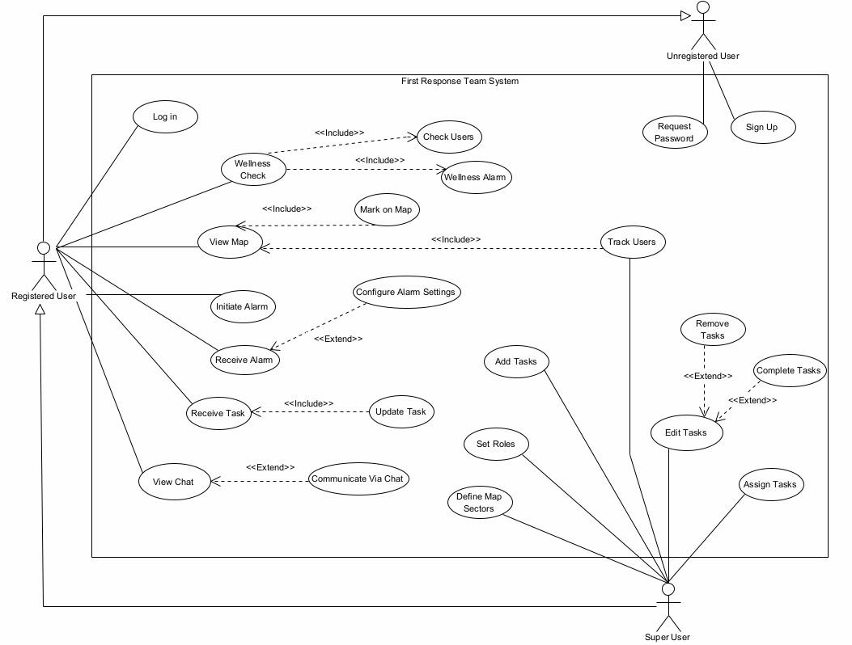

Fig 1: Use Case Diagram

**3.5 Activity Diagram**

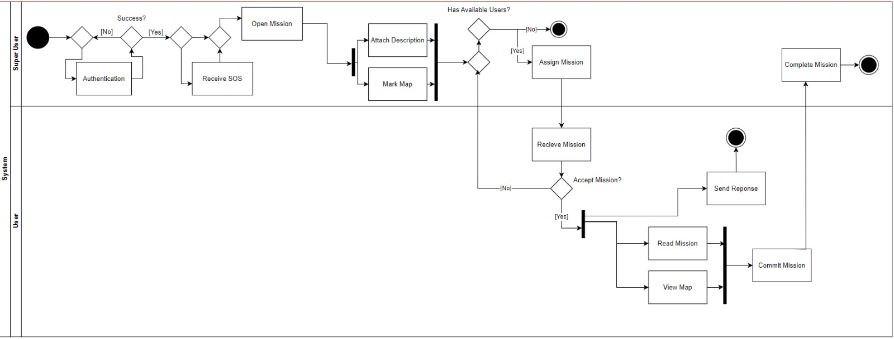

Fig 2: Activity Diagram בחירום

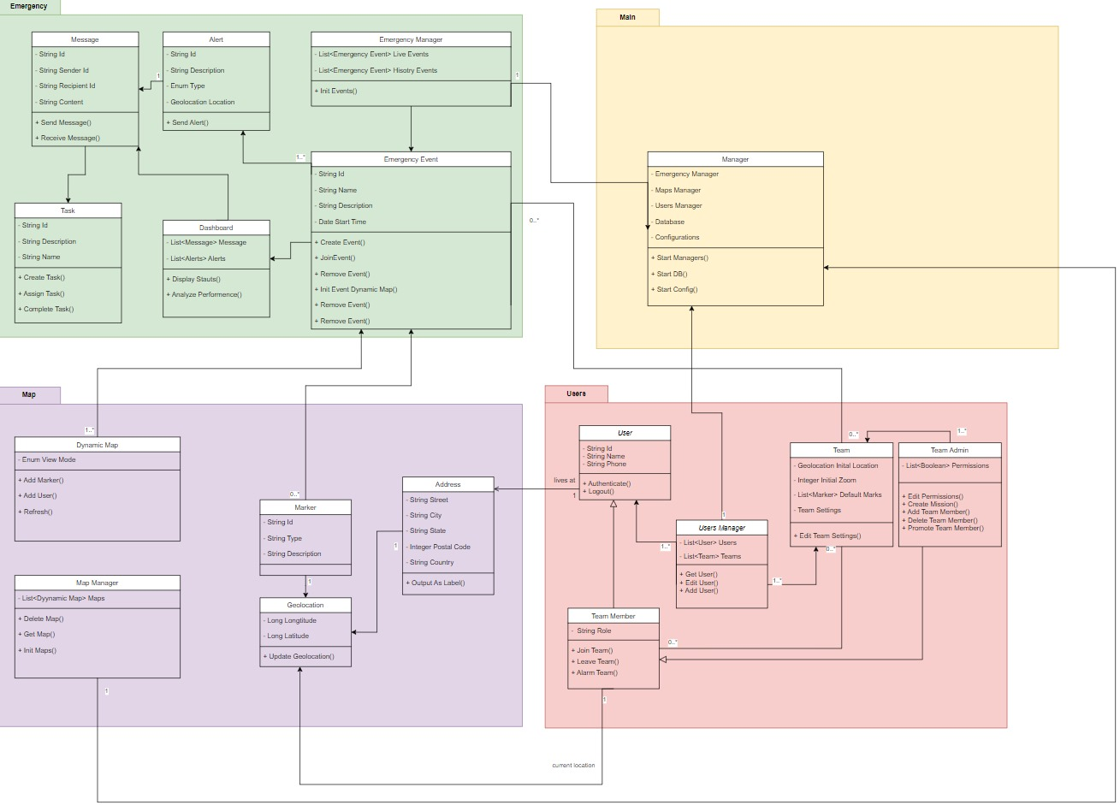

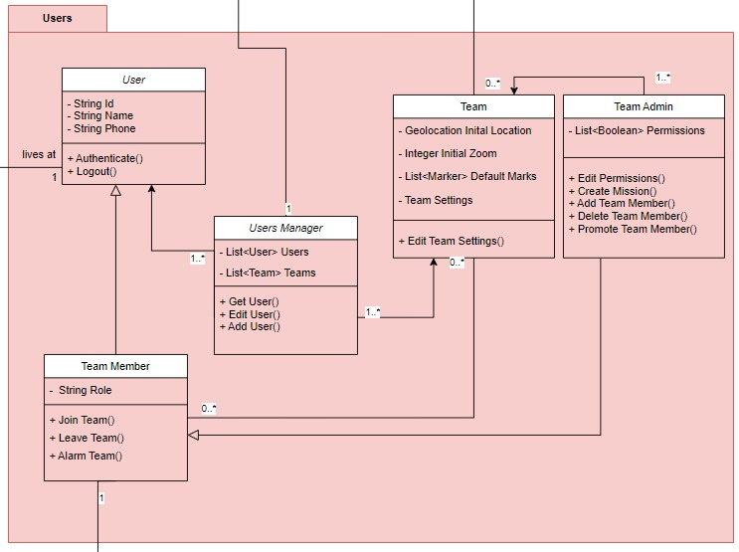

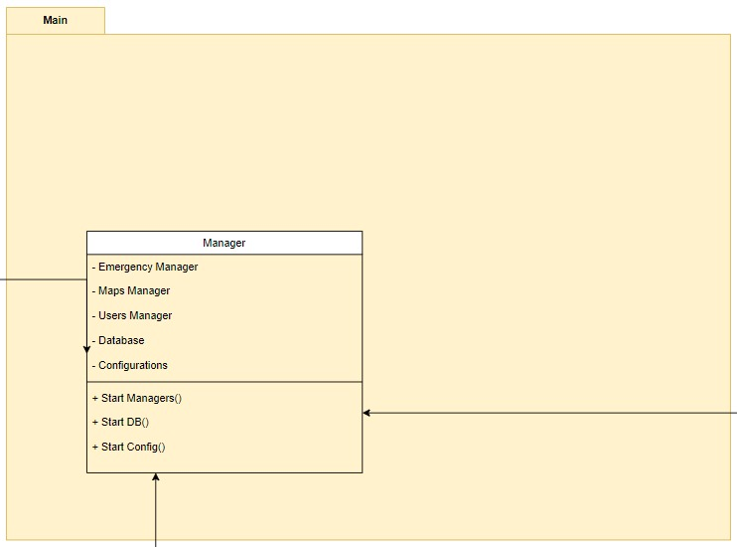

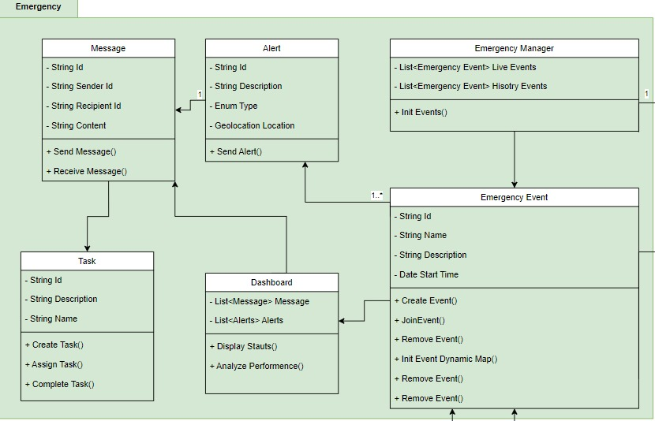

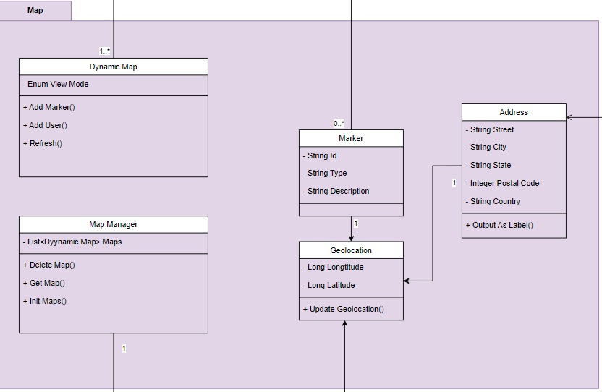

**REFERENCES**

**סידור לפי שם משפחה של כותב ראשון**[1] McWilliams, M. (2020). Creating an effective emergency response team. Professional Safety, 65(6), 66-70.‏

[2] King, R. V., North, C. S., Larkin, G. L., Downs, D. L., Klein, K. R., Fowler, R. L., ... & Pepe, P. E. (2010). Attributes of effective disaster responders: focus group discussions with key emergency response leaders. Disaster medicine and public health preparedness, 4(4), 332-338.

[3] Brown, O., Power, N., & Conchie, S. M. (2021). Communication and coordination across event phases: A multi‐team system emergency response. Journal of Occupational and Organizational Psychology, 94(3), 591-615.

[4] Boduch, A. (2017). React and react native. Packt Publishing Ltd.